Project Design Phase
Problem – Solution Fit Template

Date | 27 June 2025
Team ID | NM2025TMID00021
Project Name | Streamlining Ticket Assignment for Efficient Support Operations
Maximum Marks | 2 Marks

Problem – Solution Fit Template:

The Problem–Solution Fit phase focuses on identifying real challenges faced by support teams and designing an efficient, technology-driven solution to address them. The project aims to reduce manual effort, eliminate uneven workload distribution, and enhance service quality through an automated ticket assignment process.
By understanding the workflow gaps and performance bottlenecks in support operations, this phase ensures that the proposed solution effectively meets both user and business needs.
Purpose:
☑ Solve complex problems in support management through intelligent ticket routing and workload optimization.
☑ Improve response time and service efficiency by automating manual ticket assignments.
☑ Enhance visibility and transparency in ticket ownership and tracking.
☑ Reduce delays, confusion, and duplicate work by introducing smart prioritization rules.
☑ Strengthen collaboration and accountability across support teams.

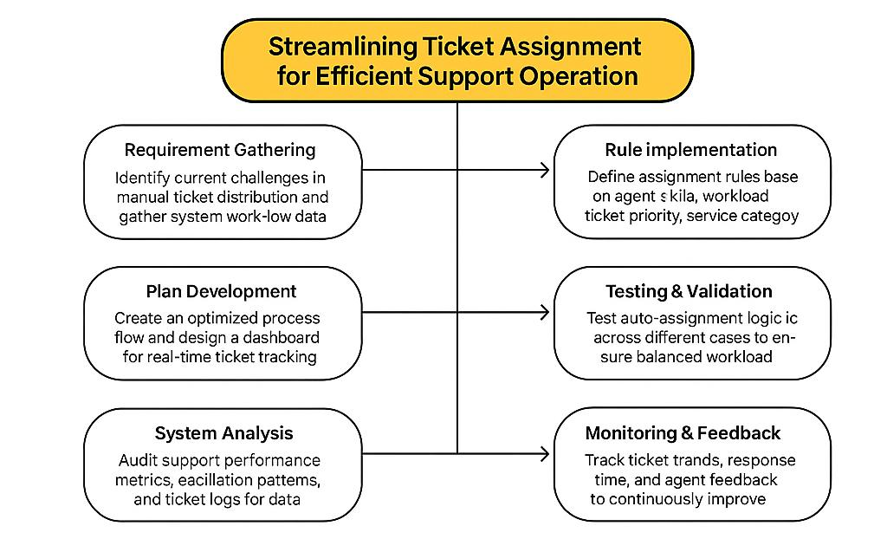
References:
- https://www.ideahackers.network/problem-solution-fit-canvas/
- https://medium.com/@epicanuts/problem-solution-fit-canvas-aa3dd59cb4fe

The project “Streamlining Ticket Assignment for Efficient Support Operation” addresses inefficiencies in traditional support systems where manual ticket allocation leads to uneven workload, delayed responses, and reduced customer satisfaction.By integrating automation within ticket routing, the solution ensures that issues are assigned to the most suitable agent or group in real time. This improves service quality, ensures fair task distribution, and enhances operational transparency. The model promotes faster resolution cycles, better utilization of resources, and measurable improvements in SLA compliance. With automated rule-based ticket assignment and continuous feedback monitoring, this system forms a strong foundation for efficient, scalable, and intelligent support operations within enterprise environments.

